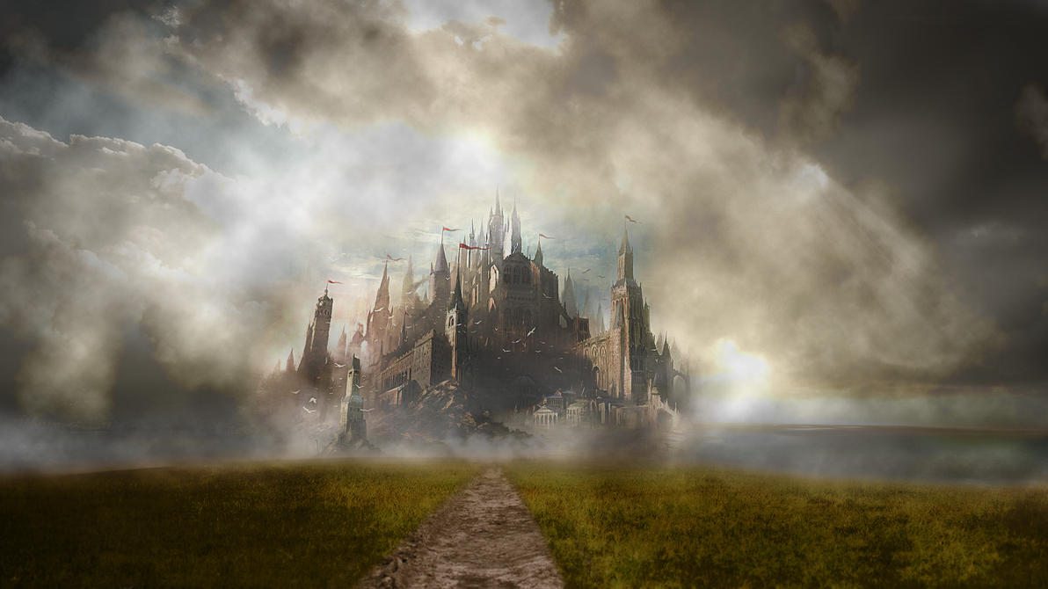

The lost city

Ahh… feel the lovely, fresh, and lush breeze of a beautiful village filled with lush green fields, grazing sheep with wool as white as the clouds in the beautiful blue sky complete with strokes of orange and sometimes even devil red just to touch up the appearance of the sky just a few hours before a rosy evening sunset.

I hurriedly urged my brother Dev who was ambitiously trying to catch one of the many white sheep on the moor, only to get kicked on the face over-and-over again, you might admire him for his determination, but to me it is just pure foolishness, anyways I was just telling him to head back to our granny’s home, eh, no point bothering he’s just going to yell five more minutes from the grassy field, and not come back till I yell at him again, I’m going to try that one more time and then leave him as a yummy snack for all the big, bad monsters out there.

Dev can sometimes be a stubborn little boy, I finally got him to listen up but at a cost… it always comes with a cost… he wanted to me to give me half of my snack today (You could call him caring but that would be pure irony), eh, no big deal I do not like them anyway, but what I do like are the hand-picked raspberries of my grandma’s backyard, oh I live for them.

When I finally, finally, finally, got Dev to listen to me, on we went towards home, the sky was already turning midnight blue with just a few streaks of sunlight left, I worried that we might not get back in time but shunned that thought at once.

As we cautiously marched our way back home, I thought it was taking too much time, the scenery changed and instead of a dusty and rocky village road, it looked like a forest a forest with short and stout, leafless and dead willow trees, suddenly a thick mist started, along with the howl of wolves, I checked back to make sure that Dev was still behind me, but he was not.

I was miserable just despised with the thought of my brother gone but I had to move on only then there was a hope a flicker of light to guide me back to him.

As I turned to continue, I saw a wolf it was tall, with a coat of snow white, just to top it off with a few spots of black and brown, and a lovely mane of jet black, unlike any other I had ever seen, it gave a feeling of strength and bravery instead of a sinister feel I had gotten from every other I had seen, it had glowing blue eyes and once I had documented it completely it ran.

Instinctively I followed the wolf, only to lose it again, this time I was on a street, something that looked like the one of my own village surrounded by a carpet of green grass but there was nothing surrounding it till all I could see, but up north I could see something, something tall and sleek with a blood red flag on top of it, somewhat like an obelisk but bade out of rocks you could find in medieval times, big and gray rocks which gave a majestic look to any royal palace, but also a mysterious and haunting look.

I moved forward only to get the haunting image clearer and clearer until the earth started rumbling, it was shaking vigorously, few of the turrets shook and the weaker ones even fell, creating a disturbing, crashing sound spewing rocks all over the place, slowly a section of the earth started rising, and there was something strange underneath, it was like a shell a turtle shell precisely, and underneath was the body of a beast a four legged beast, it was rising with the castle on its shell like projection, amidst all of this I was trying to keep myself stable and trying not to get killed.

The beast had finally risen totally, I was speechless by its sheer size let alone the mighty castle on the top of its shell, to keep it short I would describe it like this – a turtle – yes it looked exactly like a turtle, a turtle with a castle on it shell, it was blue in color with triangular spots near its limbs, its eyes glowed green and it had a red underbelly with black stripes, but there was something at the top, just above its eyes… It was Dev.